Relevant Factors to Potentially Create differences

* Class (highZQso, s82Qso, s82vStar, s82Gal, s82Star)
  + highZQso is not necessary
* Band (u, g, r, i, z)
  + g, r, and i are most important
* x_bin_size and y_bin_size
* plotColorDmDt function

How does the band type change the density map under the conditions of the **s82vStar** class, x_bin_size of **0.05** and y_bin_size of **0.01**?

*Band Type: u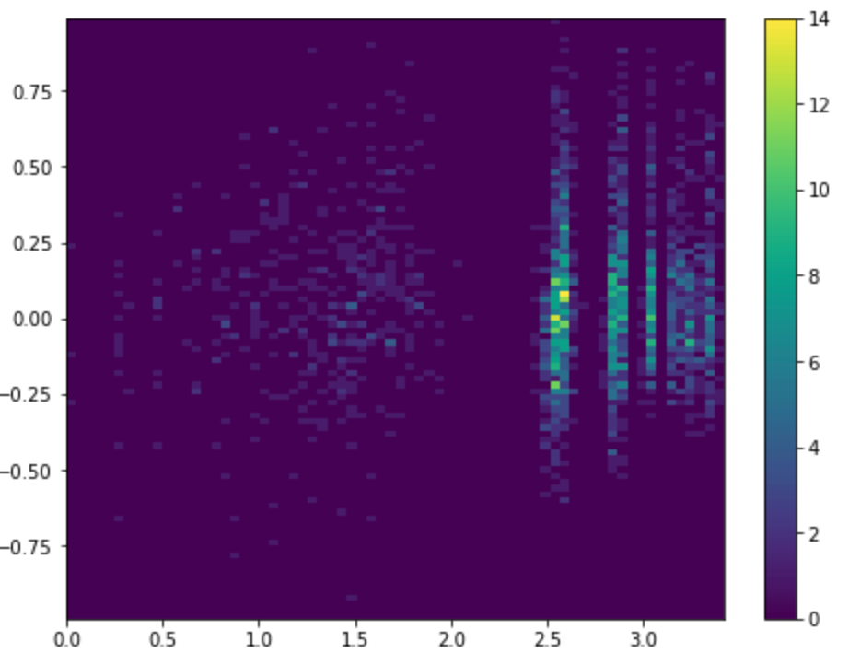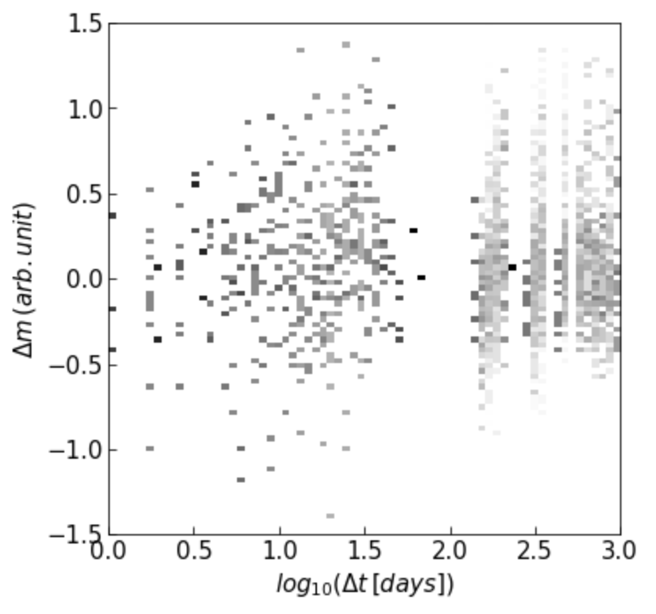

Band Type: g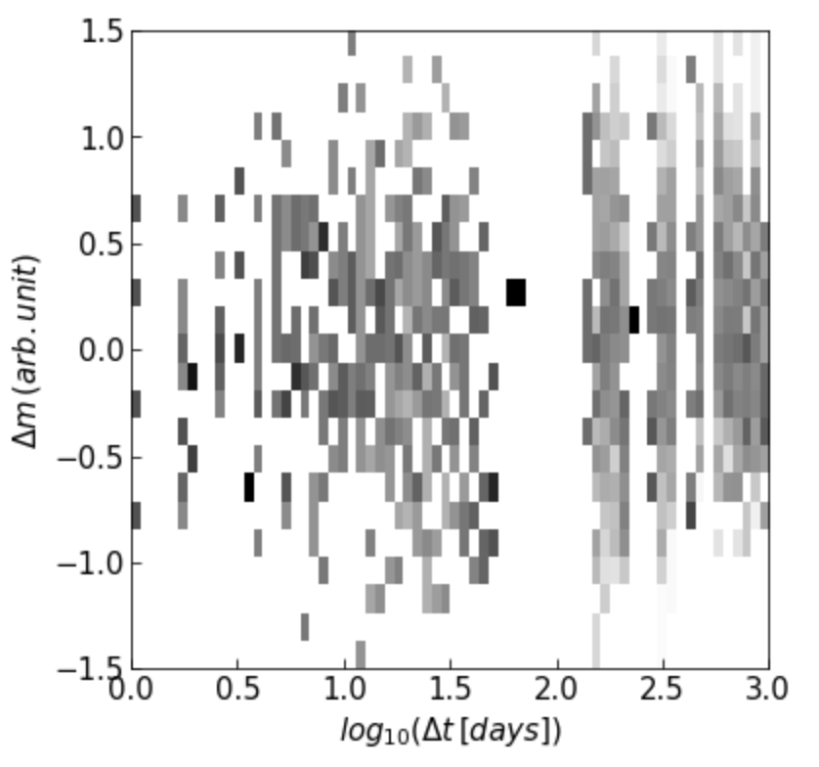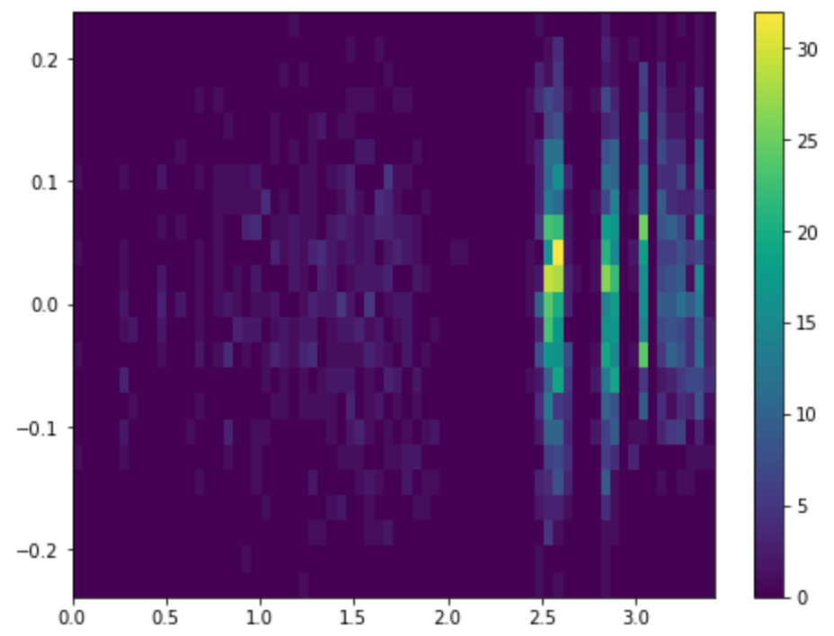

Band Type: r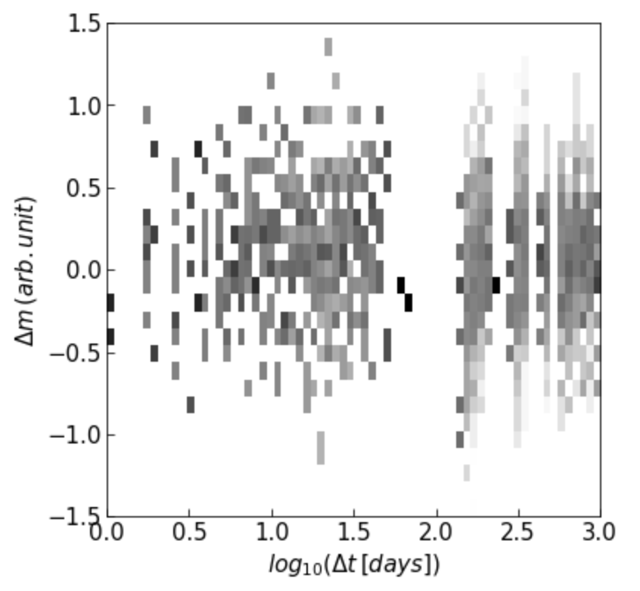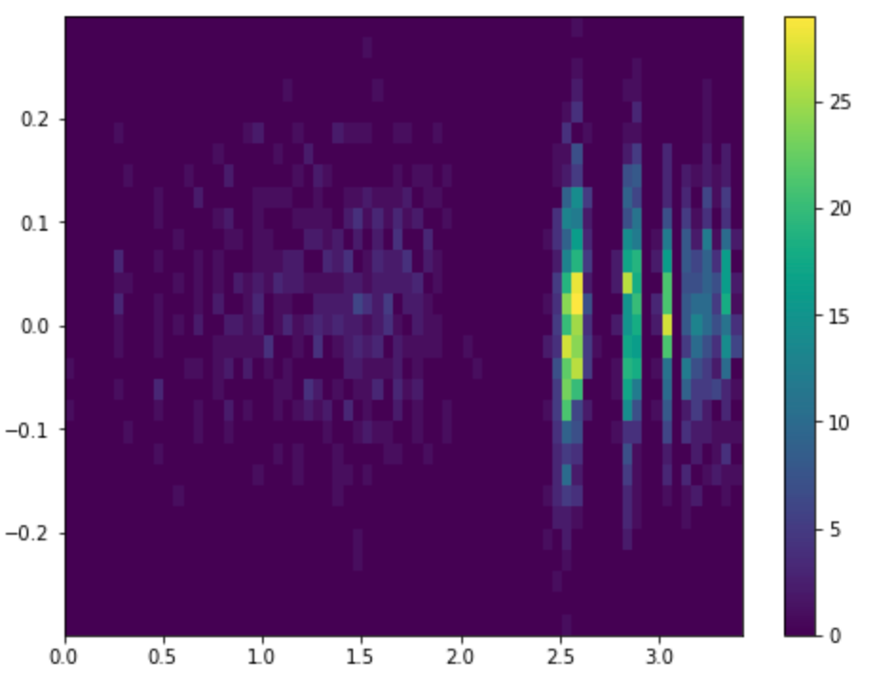

Band Type: i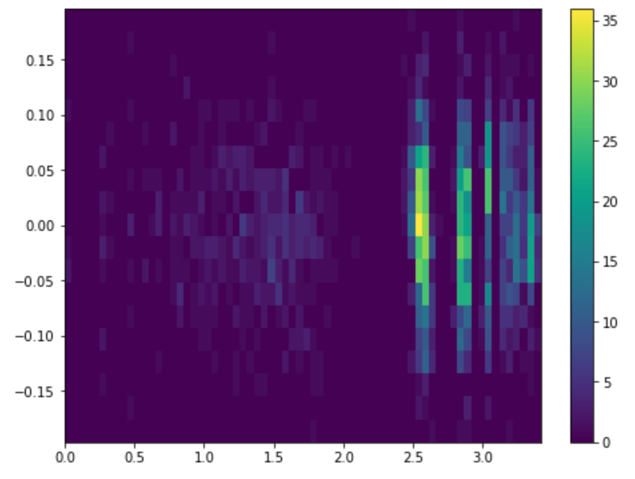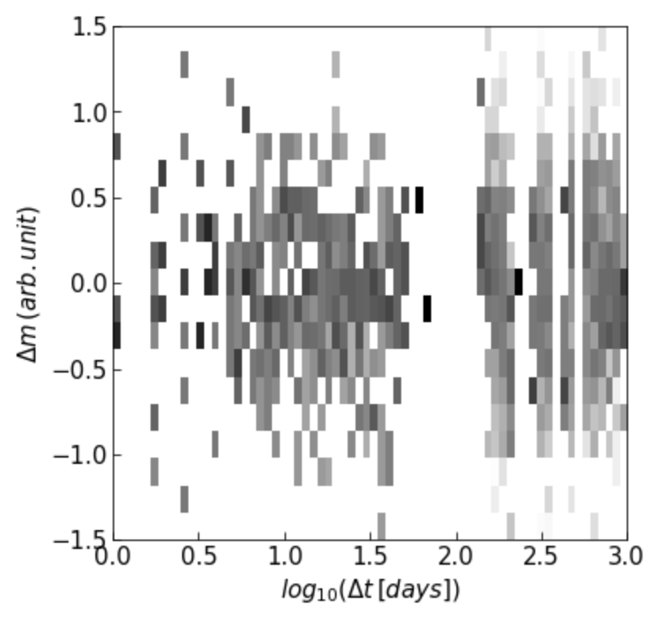

*Band Type: z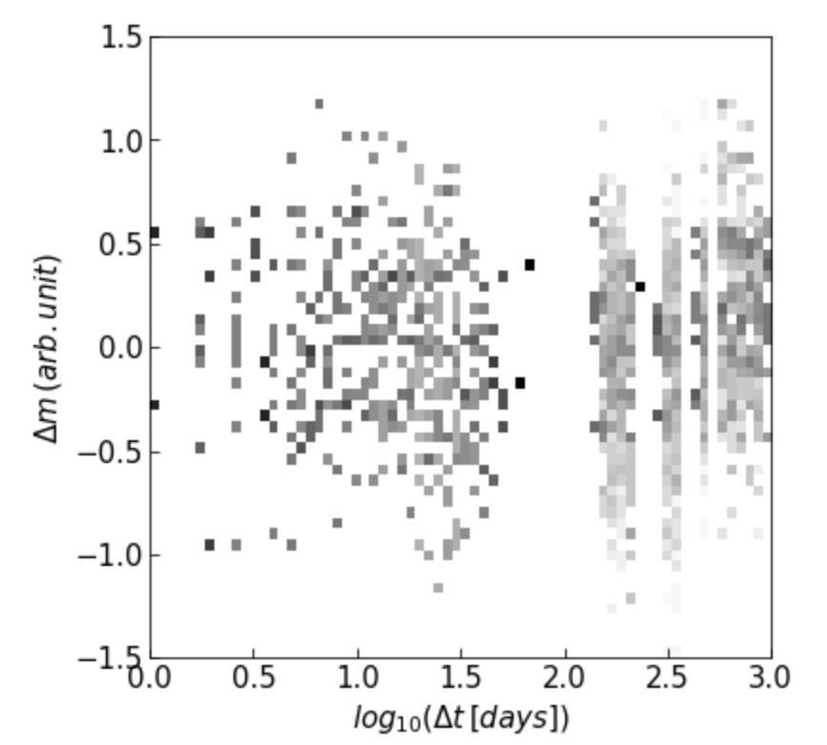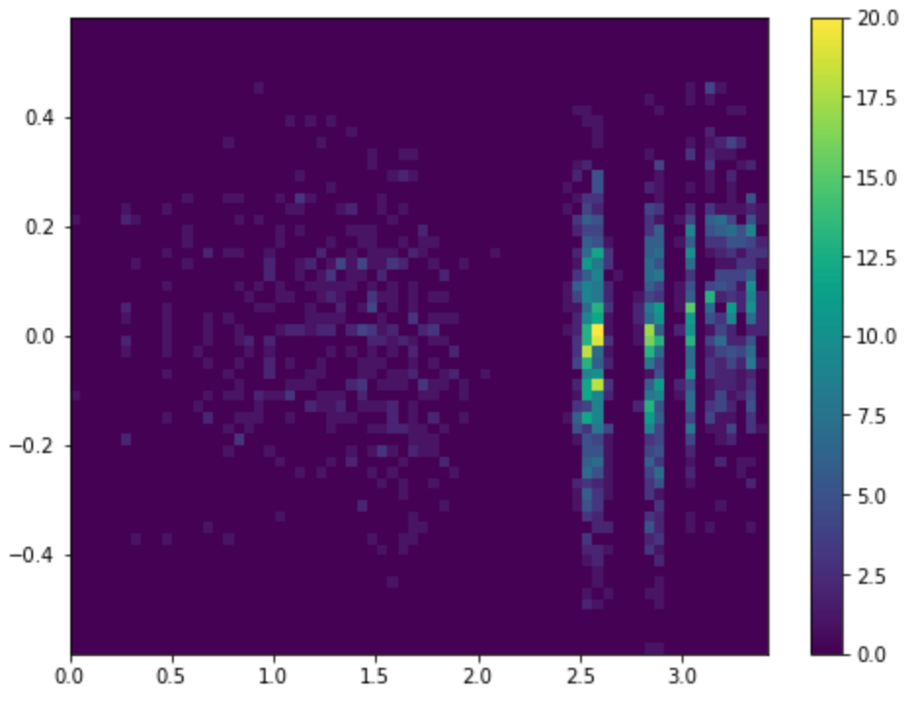

Analysis:

Maximum Density:

*U - 14 (5th)

G - 32 (2nd)

R - 29 (3rd)

I - 36 (1st)

*Z - 20 (4th)

How does the class change the density map under the conditions of band type g, x_bin_size of 0.05 and y_bin_size of 0.01?

*Class: highZQso

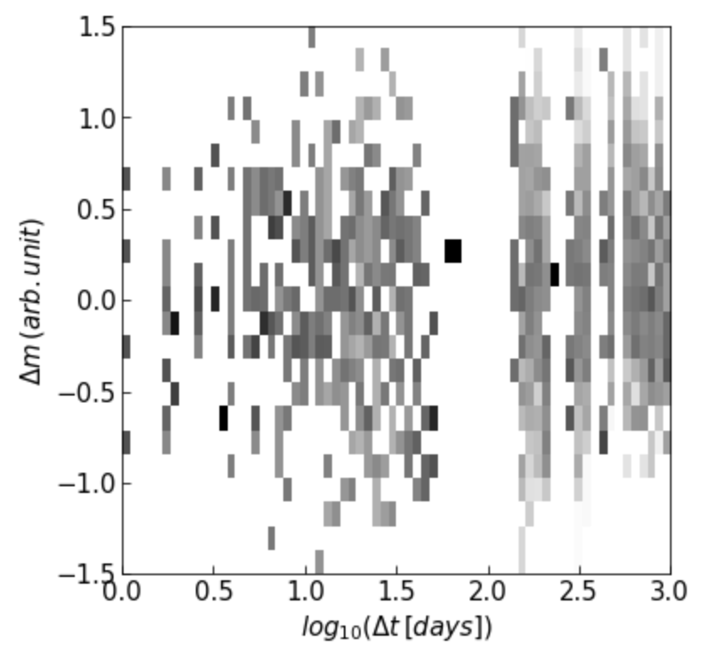

Class: s82Qso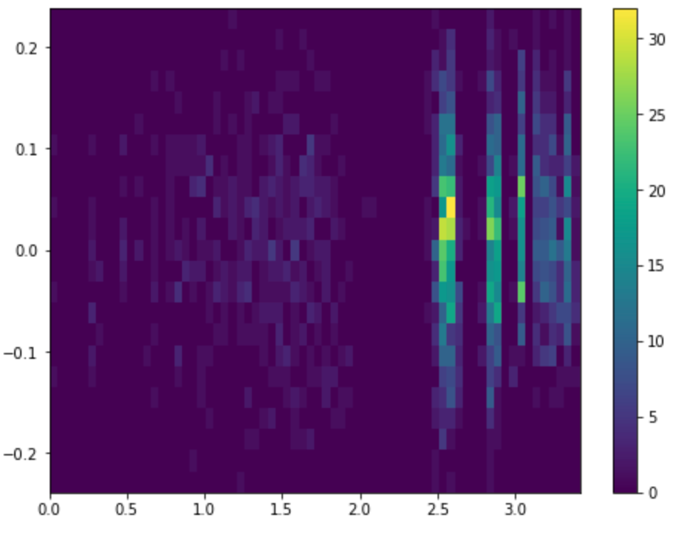



Class: s82vStar

Class: s82Gal

Class: s82Star

Do different classes change the way band types change?

Do different band types change the way classes change?

How do the x_bin_size and y_bin_size affect the density map?

-=